One Time Locale Change in Current Program Updater
Issue: Some users during installation may install the incorrect locale accidentally causing pricing issues and confusion when quoting projects in multiple Product Selection Toolbox applications. To correct this issue, a user would have to uninstall the software completely followed by a reinstall of the software. This usually was a bit involved process depending on which applications were loaded on a user’s machine.
Solution: Allow users a 1-time minimum effort chance to modify their locale selection thru Current so they do not have to go thru the long process of uninstalling/reinstalling the software.
To start this process, click on the Advanced Settings button located on the lower right location of the Current Program Updater screen.
A new window will appear. Click on the Change Locale Selection button.
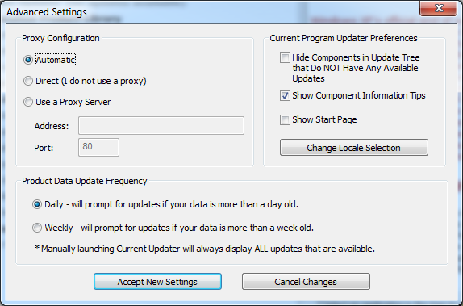
A new Switch Locales window message will appear. Please read thru the information provided in the window.
If you would like to proceed with the 1-time locale change, click on the Yes selection button. Otherwise click on the Cancel Changes button to cancel out of this operation.

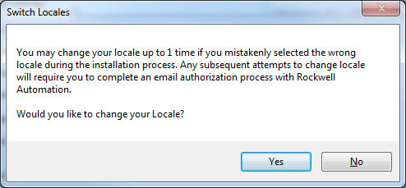
If you clicked on the Yes button from the Switch Locales window, a new PST Locale ID Selection window will appear on the screen. This is where you select your new locale. The locale selection is based on Region.
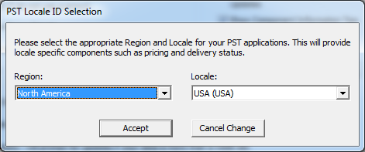
Select the Region first from the Region dropdown menu followed by selecting the appropriate locale from the Local dropdown menu:
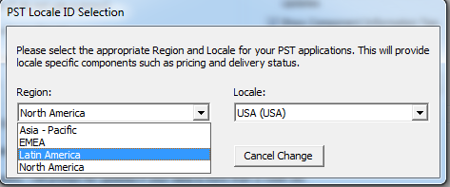
1
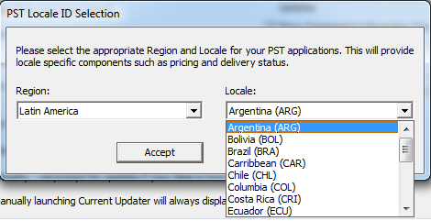
2
Once you have selected the appropriate locale, click on the Accept button. To cancel out of this operation, click on the Cancel Change button.
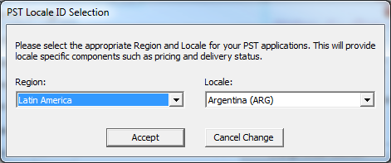
A confirmation notification will be displayed once you have clicked on the Accept button. If you clicked on the Cancel button to cancel this request, you will be brought back to the Locale ID Selection.
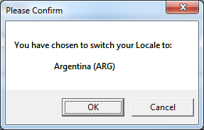
If you clicked on the OK button to finalize the process, the software will bring you back to the Advanced Settings window. Click on the Accept New Settings button to proceed with the locale change.
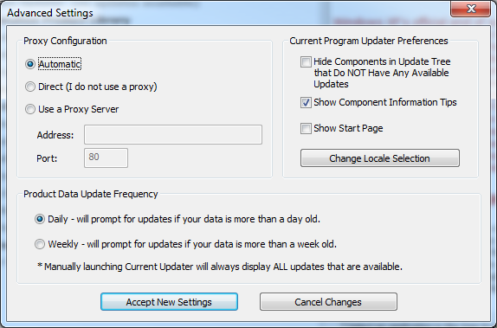
You will see a notification message of the new locale change.
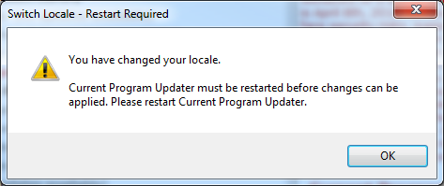
Click on the OK button to return back to Current Program Updater window. Current Program Updater will advise if there are any updates available based on the new locale change.
If you have incorrectly selected the wrong locale during the 1-time change, you will have to submit a request to the Product Selection Toolbox team to change the locale. To proceed with this request, click on the Advanced Settings button on the home page of Current Program Updater.
Now click on the Change Locale Selection button once again.
The following window message will appear:

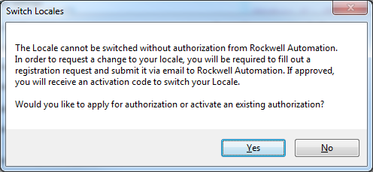
If you would like to continue with the change request, click on the Yes button. Otherwise click on the No button to cancel this request.
By clicking on the Yes button option, a new Register User window will appear. You will need to register for the new locale by completing the fields below and clicking on the Register button.
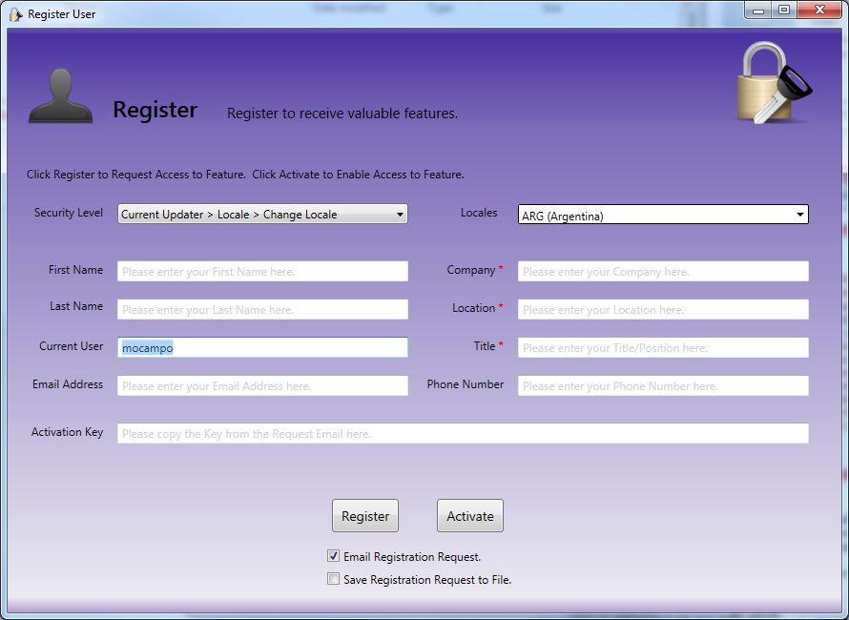
This will generate an email address to the PST Support team with your contact information and a Request ID.
Once the PST team has reviewed and approved your request, an email with a set of instructions and an activation key will be sent. Follow the set of instructions per the email to activate the new locale.
For any other questions regarding this process, please email the PST group at pst_support@ra.rockwell.com.

