Application Guide:
Configure KEPServer Enterprise as an OPC UA Server

This guide provides the steps to configure KEPServer Enterprise as an OPC UA Server.

Table of contents

1 Prerequisites 3
2 Create Windows Firewall incoming rule 4
3 Configure OPC UA settings for Project 5
4 Configure OPC UA Server endpoints 7
5 Register OPC UA server with OPC UA Local Discovery Server (LDS) 9
6 Configure OPC UA Client (FactoryTalk Linx OPC UA Connector) to communicate with OPC UA Server endpoints 11
7 Verify data from OPC UA Server with FactoryTalk Live Data (FTLD) Test Client 18

Prerequisites

Software Required
- FactoryTalk Services Platform (FTSP) V6.10 and greater
- OPC UA Local Discovery Server (LDS) 1.03.400
- KEPServer Enterprise V11.00 (6.6) or greater
Note: FactoryTalk Linx Gateway v6.10 and greater will install FTSP and includes OPC UA LDS

Ensure ‘File Name Extensions’ and ‘Hidden Items’ are checked.
- Open File Explorer, select View, and ensure ‘File Name Extensions’ and ‘Hidden items’ are checked.
or
- Show hidden files, folders, and drives.
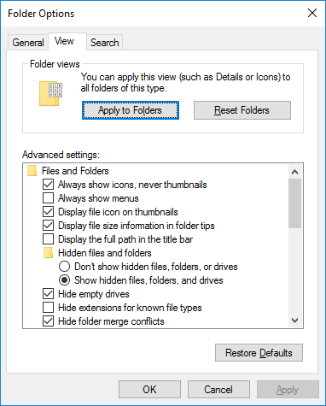

Host files in workgroup
- Configure HOSTS files for PC if in a workgroup.

Create Windows Firewall incoming rule.

Create the Windows Firewall Incoming rule for KEPServer Enterprise:
- Open a CMD with admin rights and enter the following:
Netsh advfirewall firewall add rule name="OPC UA - KEPServerEnterprise" dir=in profile=domain,public action=allow program=any protocol=tcp localport=49370
- Select Enter to run the command.
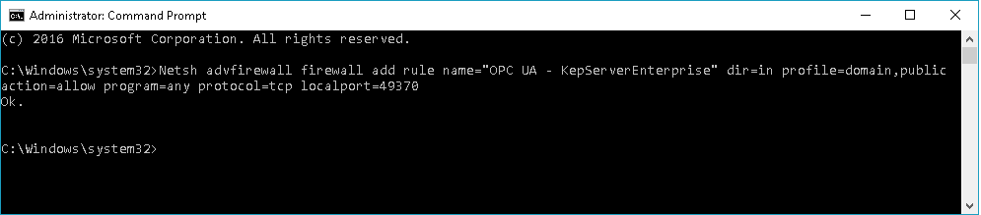

Open ‘Windows Firewall with Advanced Security’ to verify the entry(s) was created successfully.
- Select Windows Start, type ‘Windows Firewall with Advanced Security’, and click to open the utility.
- Scroll down and verify 'OPC UA - KEPServerEnterprise' is listed
- Scroll to the right to see the port number 49370 is listed.
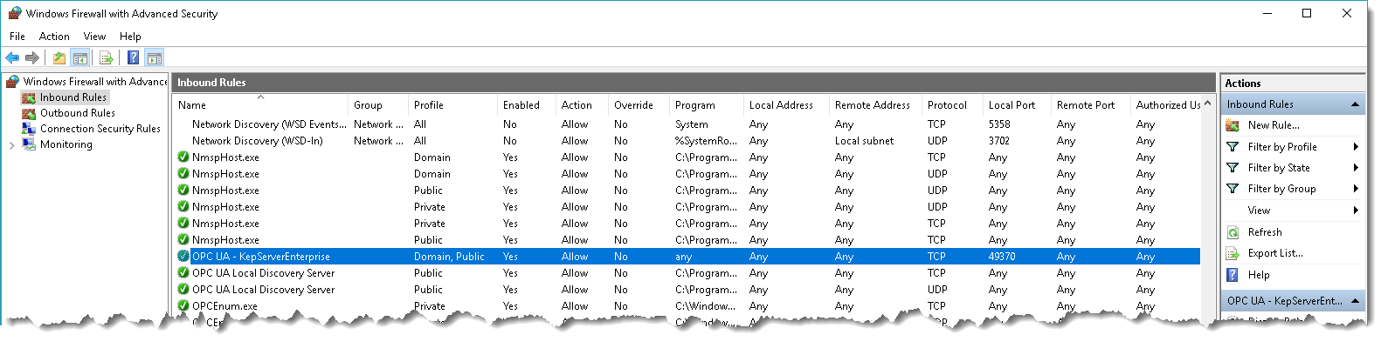
Note: The ‘Windows Firewall with Advanced Security’ utility can be used to create the incoming firewall rule by right-clicking ‘incoming rule’ and using the wizard with the parameters listed in the Command line above.

Configure OPC UA settings for Project.

Open KEPServer Enterprise Configuration utility
- Right-click on the KEPServer Enterprise icon in the system tray and select ‘Configuration’.
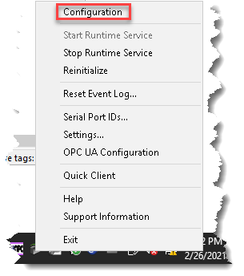

Open the KEPServer Enterprise project.
- Select File -> Open, browse to the KEPServer Enterprise project.
(e.g., C:\Program Files (x86)\Kepware\KEPServerEnterprise 6\Projects\simdemo.opf)

Configure OPC UA settings for projects.
- Right-click on ‘Project…’ and select Properties.
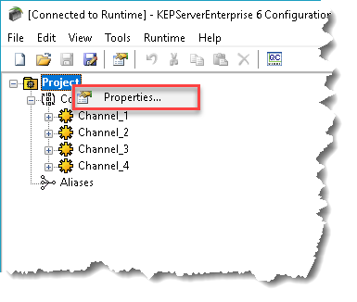
- On the left, under Property groups, Select 'OPC UA'
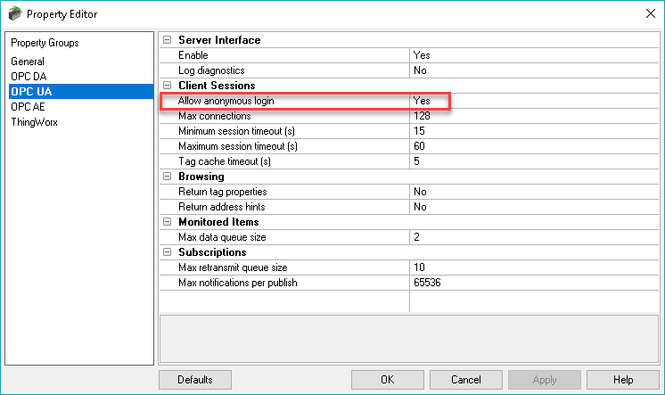
- Verify if 'Allow Anonymous Login' is set to Yes.
  - Set to ‘Yes’, when initially configuring to verify OPC UA Client-Server connection.
  - Set to ‘No’ for additional layer of security.
- Leave 'Allow Anonymous Login' set to Yes.
Note:
- When set to Yes, a username and password are not required to establish a connection.
- If set to No, users cannot login as the default user in the User Manager. Users can login as the Administrator (provided that a password was set during installation.)
- Use 'User Manager' to set a password for ‘Administrator’ or create a new user and set all user permissions.
- See the help for additional details.

Configure OPC UA Server endpoints

Launch KEPServer Enterprise OPC UA Configuration utility
- Right-click the Kepware icon in the System Tray and select "OPC UA Configuration" from the pop-up menu.
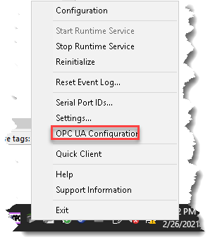
- Select the "Server Endpoints" tab
- Highlight the URL ‘opc.tcp://127.0.0.1:49370’ entry and uncheck the “Enabled” box.
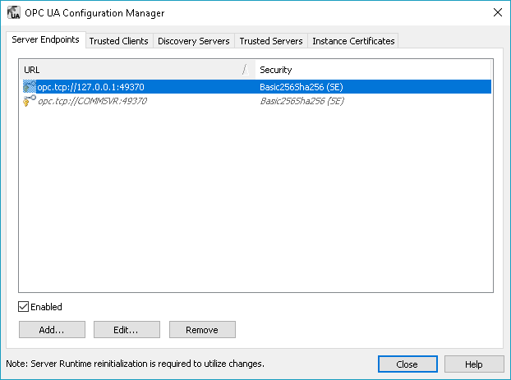
- Highlight the URL ‘opc.tcp://{MachineName}:49370’ selection and check the "Enabled" box.
- With the URL ‘opc.tcp://{MachineName}:49370’ selection highlighted, Select the 'Edit…' button.
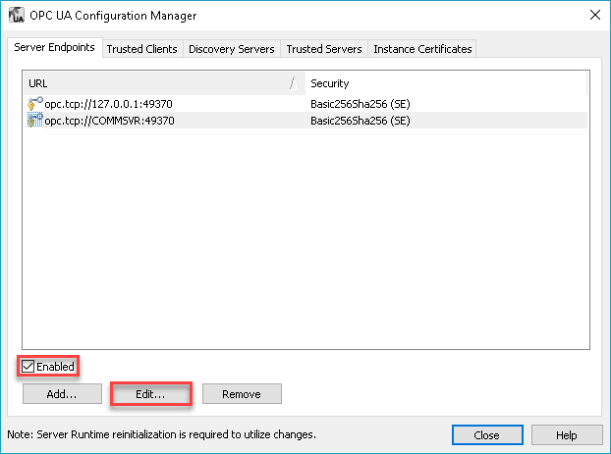
- Check the policies supported by the OPC UA Client.
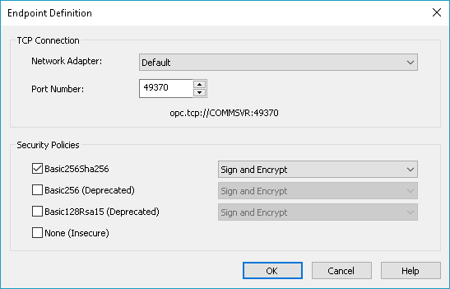
- Select 'OK'"
- Leave the OPC UA Configuration Window Open.

Register OPC UA server with OPC UA Local Discovery Server (LDS)

Configure KEPServer Enterprise to trust OPC UA LDS
- On the OPC UA Configuration Manager, Select the "Discovery Servers" tab.
- Click the "Import..." button.
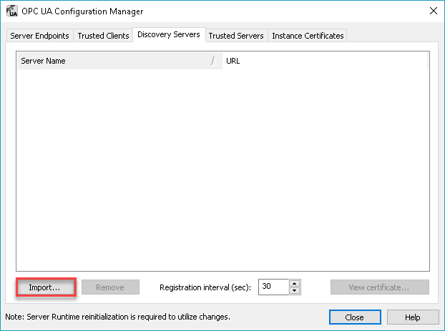
- Navigate to the following location and select the file:
C:\ProgramData\OPC Foundation\UA\pki\own\certs\ualdscert.der"
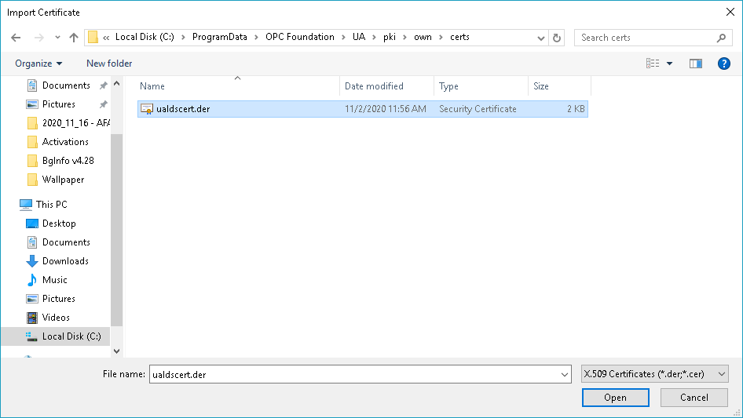
- Click ‘Open’.
- Double-click the URL and change 'localhost' to the PC name where KEPServer Enterprise is installed.
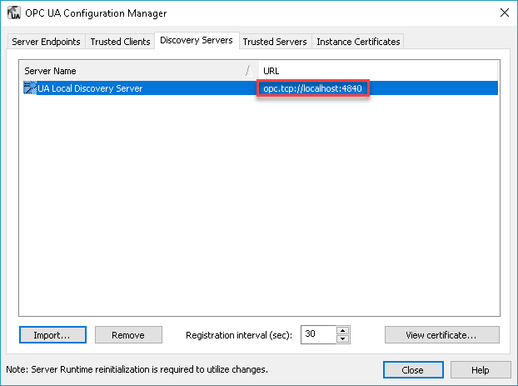
- Close the OPC UA Configuration Manager Window.

Configure OPC UA LDS to trust KEPServer Enterprise.
- Open File Explorer
- Copy the KEPServer Enterprise Certificate to the OPC UA LDS trusted folder location:
- Copy the file “kepserverenterprise_ua_server.der” from the folder "C:\ProgramData\Kepware\KEPServerEnterprise\V6\UA\Server\cert
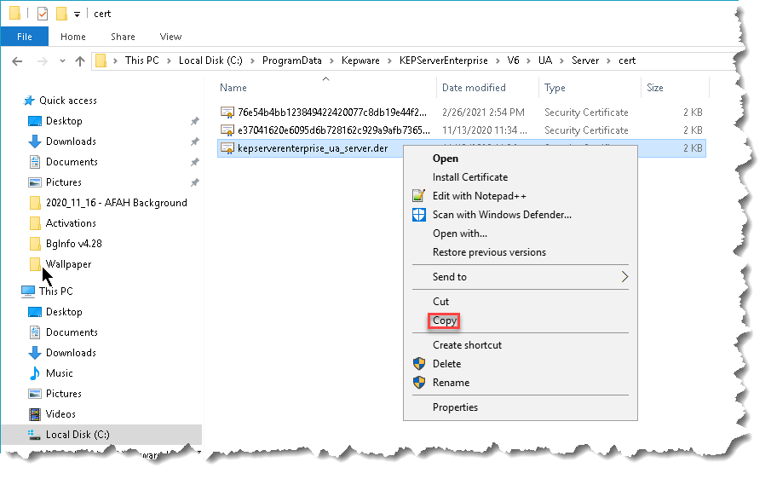
- Paste the file into the folder:
"C:\ProgramData\OPC Foundation\UA\pki\trusted\certs"
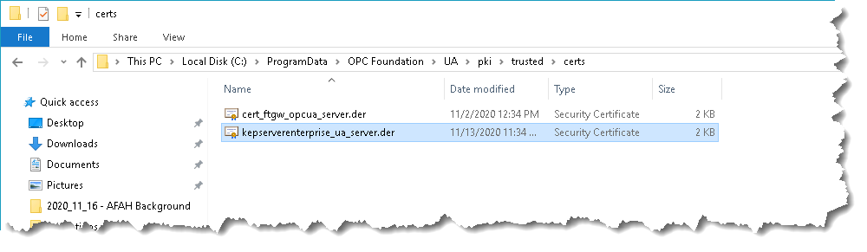

Configure OPC UA Client (FactoryTalk Linx OPC UA Connector) to communicate with OPC UA Server endpoints

Create FactoryTalk application
- Open FactoryTalk Administration console
- Select Network
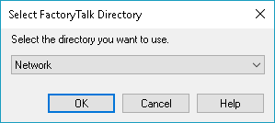
- Create a new application.
  - Right-click on Network
  - Select new application.
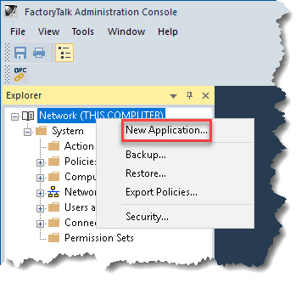
  - Type in a name (e.g., TestApp)
  - Click OK.
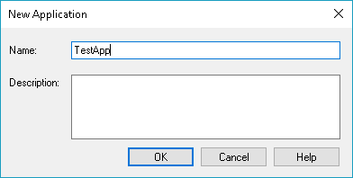
- Create a new area.
  - Right-click Application name (e.g., TestApp)
  - Select 'New Area…'
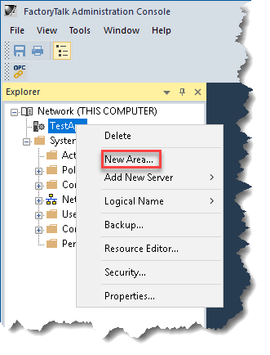
  - Type in a name for the area (e.g., OPC UA Server Area)
  - Click OK
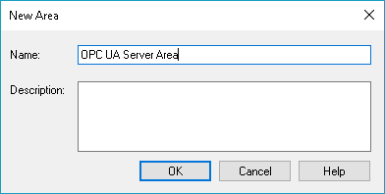

Create OPC UA Connector
- Right-click on the area (e.g., OPC UA Server Area) and select 'OPC UA Server….'
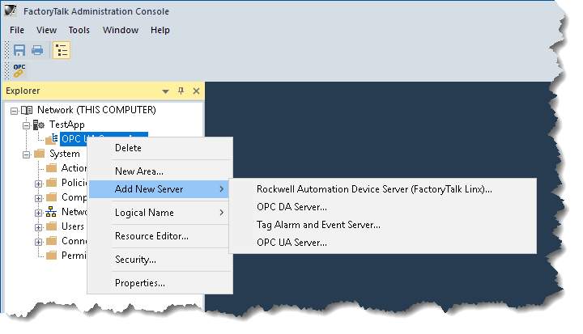
- Name the connector (e.g., 'TestConnector')
- Select the PC which will host the service.
  - Use the default PC.
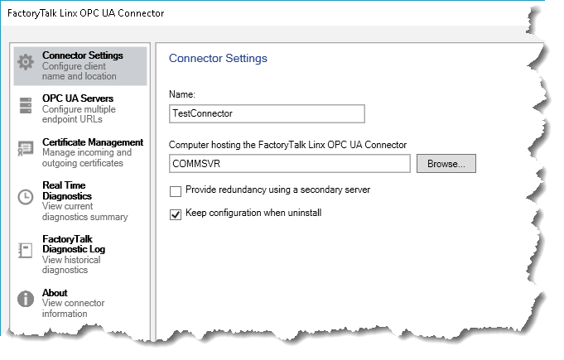

If OPC UA Server is registered with OPC UA LDS, browse for OPC UA Endpoints.
- Click 'OPC UA Servers' tab
- Under Name, type in a name for the Server endpoint (e.g., KEPSvrEnt)
- Under the heading 'Endpoint URL’, Click the button '…' to browse OPC UA LDS for UA Servers
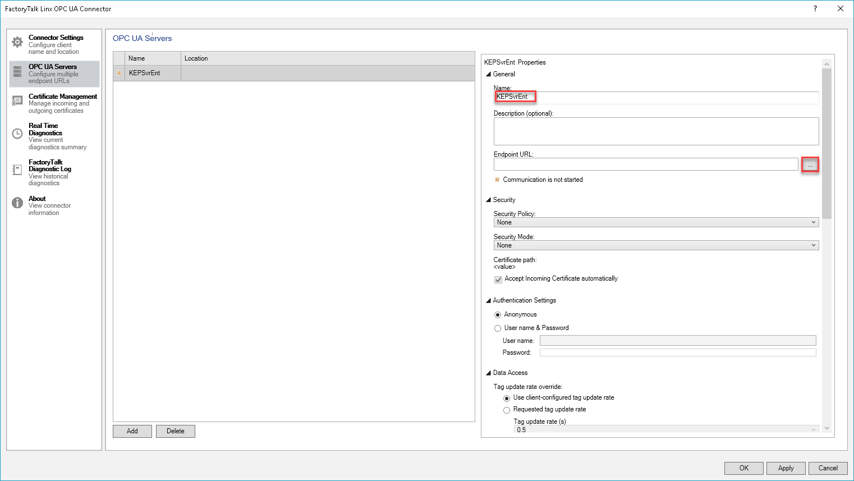
- On the 'Server Endpoint URL' window, Click Local -> KEPServerEnterprise/UA@{PC Name}
- Click the endpoint:
'opc.tcp://{PC Name}:49370|SignAndEncryptBasic256Sha256'
- Click 'Select' to add the endpoint.
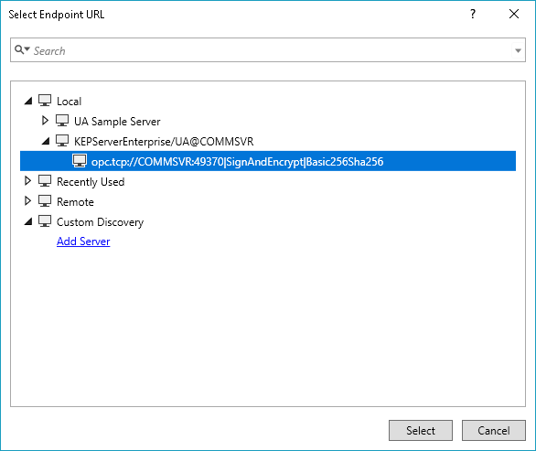
- Click 'Apply' to start the OPC UA Connector service.
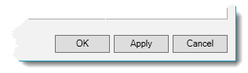
Note1: The FactoryTalk OPC UA Connector (OPC UA Client) does not generate its certificate until its service is started.

Note2: The FactoryTalk OPC UA Connector (OPC UA Client) contains an option to ‘Accept Incoming Certificate Automatically’ (i.e., Trust OPC UA Servers automatically)
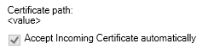

(Optional) If UA Server is NOT registered with OPC UA LDS, manually add UA Server endpoints.
- Under 'Endpoint URL:'
- Type in the address for the OPC UA server endpoint
  - opc.tcp://{PC Name}:49370
- Configure security settings for endpoints.
  - Select security policy.
  - Select security mode.
- Configure Authentication Settings
  - ‘Anonymous’ (if the UA Server supports this settings)
Or
  - Enter Username and Password required for the endpoint.
- Click apply to start the OPC UA Connector service

Check OPC UA connection status.
- Underneath the Endpoint URL, the following connection status will be displayed.
  - ‘Communication is not started.’
  - ‘Connecting with server.’
  - ‘Disconnected with server'.
- Leave the ‘FactoryTalk Linx OPC UA Connector’ window open.
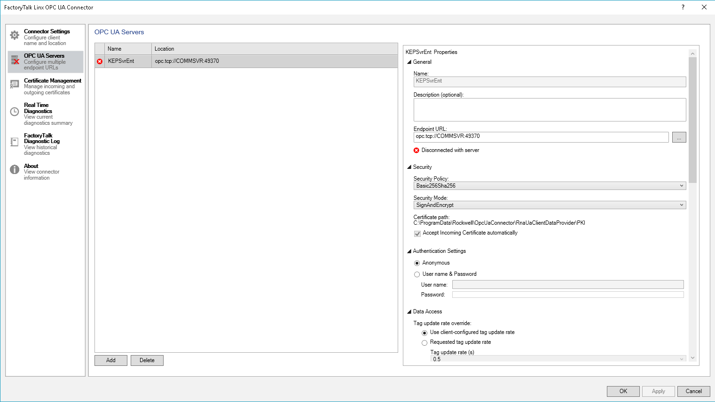

Note: If the status displays ‘Disconnected with server.’ The most likely cause is that KEPServer Enterprise has not been configured to trust the OPC UA Client (FactoryTalk OPC UA Connector)

If the status displays ‘Disconnected with server.’
- Right-click the KEPServer Enterprise icon in the System Tray and select "OPC UA Configuration" from the pop-up menu.
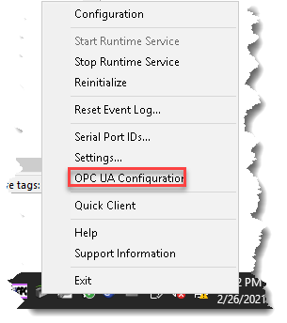
- Select the "Trusted Clients" tab
- Select 'FactoryTalk Linx OPC UA Connector' in the list
      - Check if there is a red 'X' to the left of the name.
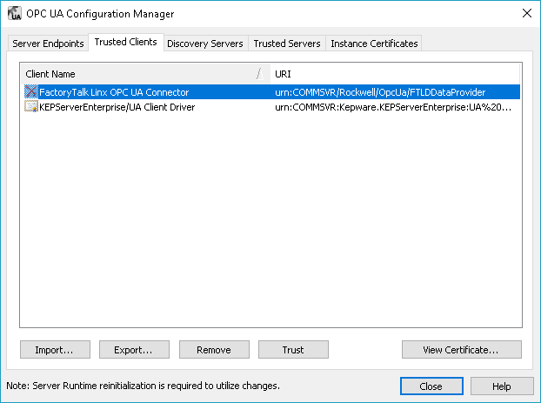
- Click the 'Trust' button
      - The red 'X' will be removed.
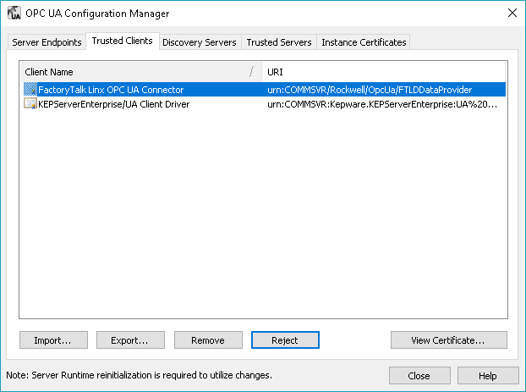
- Click 'Close'
- On the 'FactoryTalk Linx OPC UA Connector’ window
- Underneath the Endpoint URL, check the connection status.
- After approx. 10 seconds, the connection status will display 'Communicating with Server.'
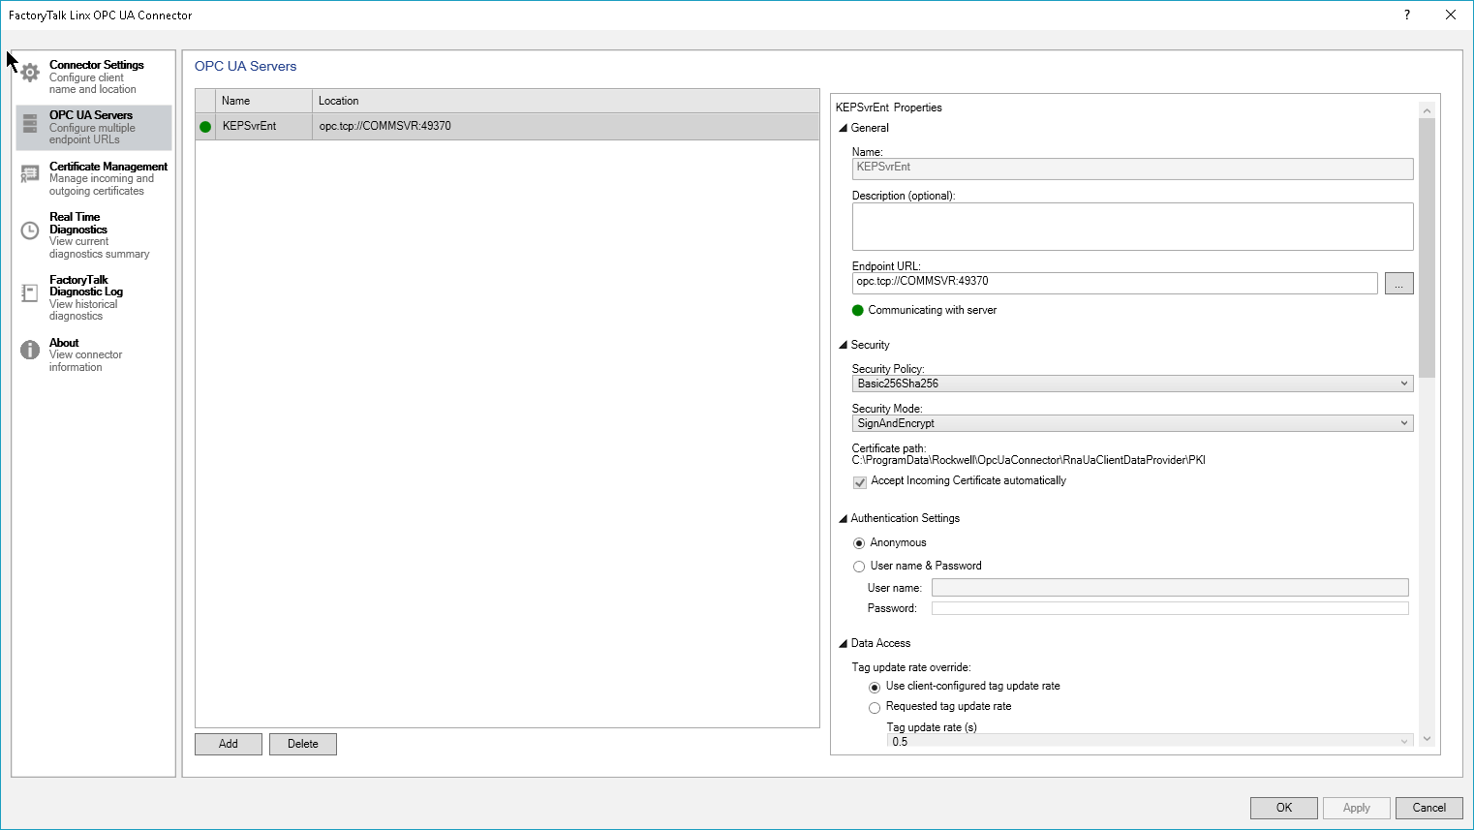

Verify data from OPC UA Server with FactoryTalk Live Data (FTLD) Test Client

Open FactoryTalk Live Data Test Client
- On the Initial Connection Window
- Select the 'FactoryTalk' radial button.
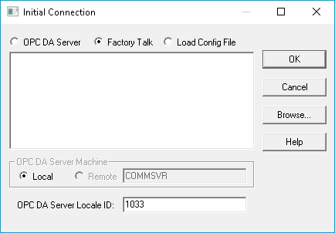
- Select 'Network’
- Click OK
- Highlight the Application (e.g., TestApp)
- Click OK
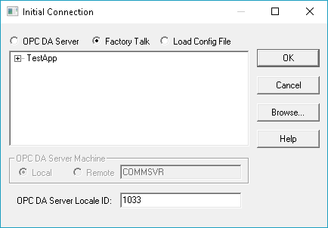
- On the 'Create Group' window, click OK.
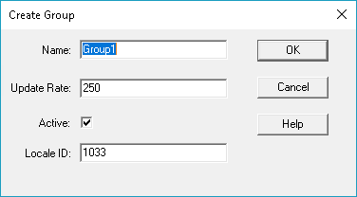
- On the 'Add Item' Window, browse for tags.
    - Navigate to Area name -> Connector name -> OPC UA Server Name
      - (e.g., OPC UA Server Area->TestConnector->KEPSvrEnt)
    - Continue to 'Channel' -> 'Device1', the tags will be listed.
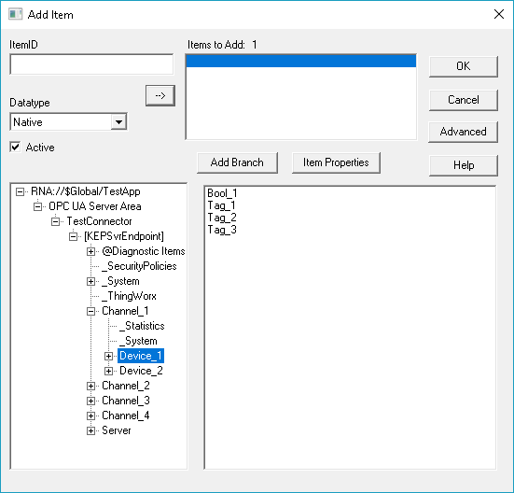
    - Double-click tags individually to be added. Or
    - Click 'Add Branch' to add all tags listed right hand window.
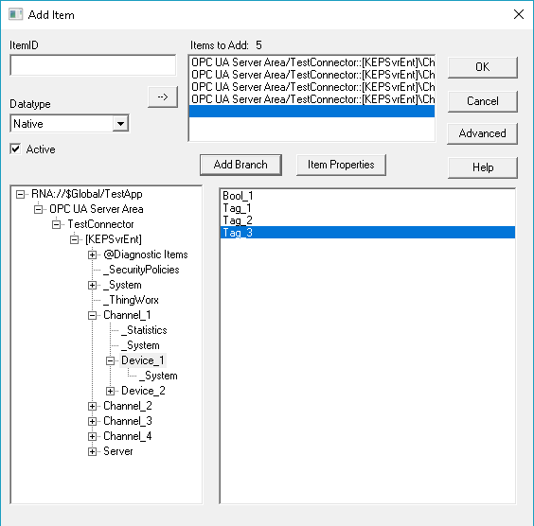
    - Click OK to monitor the tags.
  - Verify for all tags 'Current Quality' displays 'Good’.
