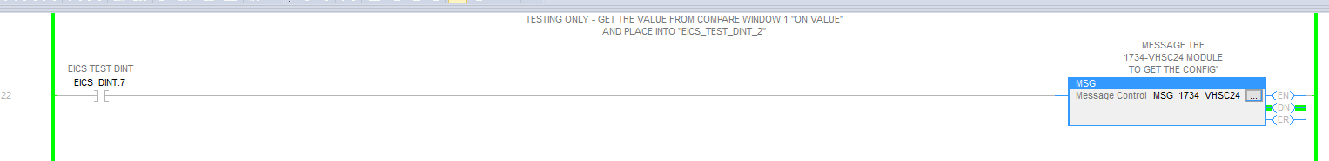

* Msg - Get the Value

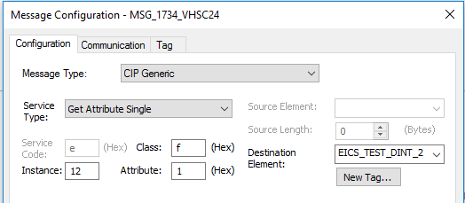

* Msg - Set the Value

